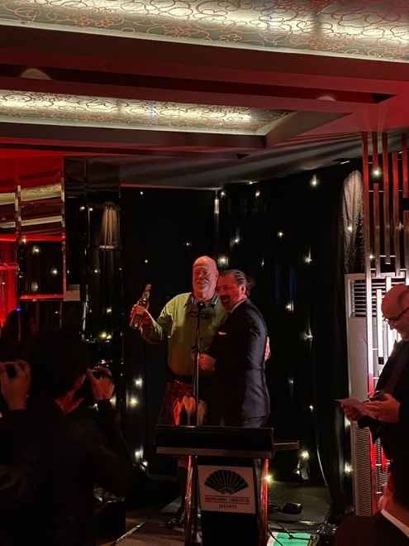
Following a 2-year hiatus, due to the pandemic, The RIO Club was back as sponsor of the Java St. Andrew Society’s 2023 Burns Supper. A great way to start off our 28th year of sponsorship given our long standing relationship with the society.

We were of course proud to sponsor a return flight for Dougie Smith, a Burns Aficionado who had travelled from Scotland, to make sure the guests were enchanted and entertained by Rabbie Burns’ poems and songs.

Colin Singer was the winner of the RIO Club Free draw and as such received a fine bottle of 25-year-old single malt presented by RIO’s John Brown seen in the photo to the right.

The RIO Club

