The RIO Club is proud to have once again sponsored the Priscilla Hall Memorial Foundation annual golf tournament held at Cengkareng Golf Club.

Proceeds from the event partly were donated to the Earthquake victims in Cianjur, West Java with the remaining balance used to support the foundation's current and future projects in making a difference to the young Indonesian children's lives.

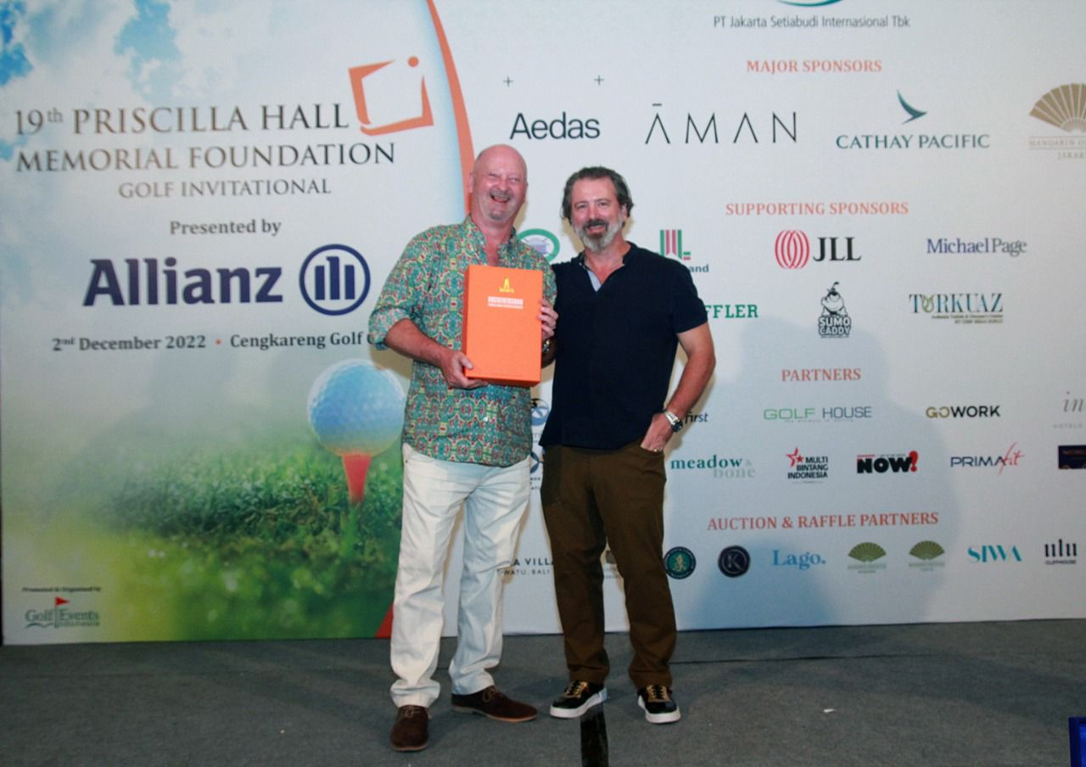

Chris Wooten was the winner of the RIO Club Free draw and was presented with an excellent bottle of single malt from RIO’s John Brown.

